**[How to Enable New Siri UI (Apple Intelligence UI) on iPhone and Mac](https://forum.betaprofiles.com/t/how-to-enable-new-siri-ui-apple-intelligence-ui-on-iphone-and-mac/13887)**

You’ve probably seen posts sharing about the new Siri UI in iOS 18 on X, Threads, etc., but [iOS 18 Developer Beta 1 60](https://forum.betaprofiles.com/t/whats-new-in-ios-18-beta-1/13444/7) currently hasn’t added any new features related to Siri.

Good news! You can experience the new Siri user interface early with a few tips below.

[[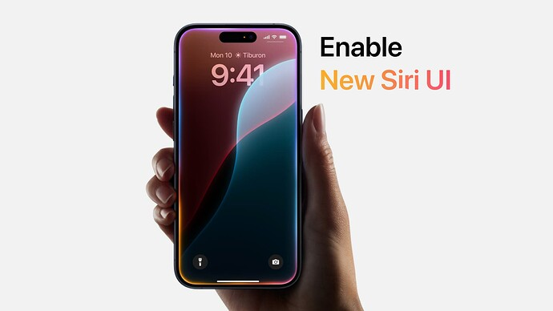](https://forum.betaprofiles.com/uploads/default/original/2X/4/41829877f75e7c4864b8cda2e72aa25ea2357958.jpeg)](https://forum.betaprofiles.com/uploads/default/original/2X/4/41829877f75e7c4864b8cda2e72aa25ea2357958.jpeg" \o "enable-new-siri-ui)

[enable-new-siri-ui1920×1080 52.5 KB](https://forum.betaprofiles.com/uploads/default/original/2X/4/41829877f75e7c4864b8cda2e72aa25ea2357958.jpeg" \o "enable-new-siri-ui)

 **To clarify, this only activates the new Siri user interface; features related to Apple Intelligence will not work at this time.**

The new Siri UI works with all iPhones and iPads running iOS 18/iPadOS 18 Developer Beta 1. However, only devices with M1 or A17 Pro chips and above will utilize Apple Intelligence features when they are released.

* [What’s New in iOS 18 Beta 1 60](https://forum.betaprofiles.com/t/whats-new-in-ios-18-beta-1/13444/7)

**Before You Begin**

* You should back up your device before performing any of the steps below. Your data is invaluable, and I will not be responsible if you do not back up your device.
* Temporarily turn off Find My iPhone/iPad in **Settings [your Apple ID] - Find My - Find My iPhone or iPad.**
* You will need a Mac or Windows PC.

**Enable New Siri UI on iPhone**

**For Mac**

1. Download and install Cowabunga Lite for Mac (you can easily find it on Google).
2. Connect your device via USB cable.
3. Open Cowabunga Lite and click on the **Custom Operation** tab in the left column.

[[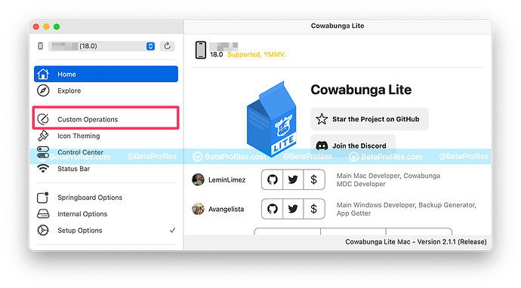](https://forum.betaprofiles.com/uploads/default/original/2X/3/38e1f9987cc7dc4f68313256e0449354a36da6dd.png)](https://forum.betaprofiles.com/uploads/default/original/2X/3/38e1f9987cc7dc4f68313256e0449354a36da6dd.png" \o "enable-new-siri-ui-cowabunga-lite-1)

[enable-new-siri-ui-cowabunga-lite-11200×666 183 KB](https://forum.betaprofiles.com/uploads/default/original/2X/3/38e1f9987cc7dc4f68313256e0449354a36da6dd.png" \o "enable-new-siri-ui-cowabunga-lite-1)

1. Click the **Import .cowperation** button, select the *iOS_18_Siri.cowperation* file ([download here 381](https://bit.ly/siri-18)).

[[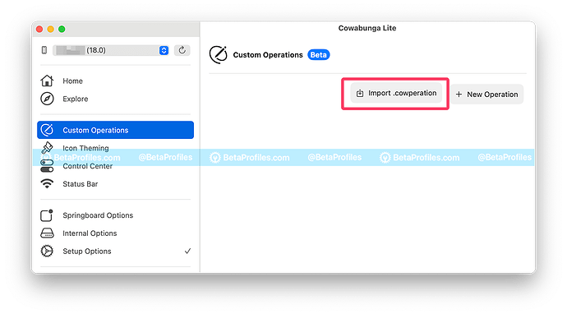](https://forum.betaprofiles.com/uploads/default/original/2X/6/652d7829df094bed88a32d6889f337d98a3d6bb9.png)](https://forum.betaprofiles.com/uploads/default/original/2X/6/652d7829df094bed88a32d6889f337d98a3d6bb9.png" \o "enable-new-siri-ui-cowabunga-lite-2)

[enable-new-siri-ui-cowabunga-lite-21200×666 128 KB](https://forum.betaprofiles.com/uploads/default/original/2X/6/652d7829df094bed88a32d6889f337d98a3d6bb9.png" \o "enable-new-siri-ui-cowabunga-lite-2)

[[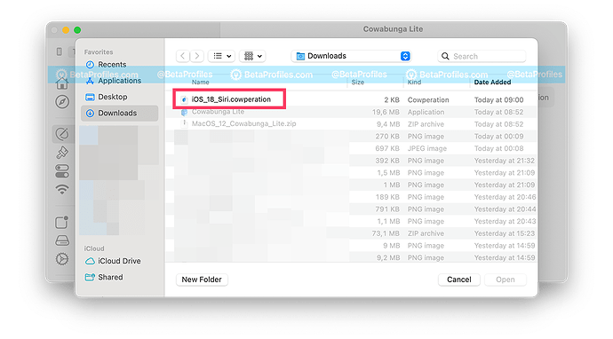](https://forum.betaprofiles.com/uploads/default/original/2X/e/e791bca2611c248cd97715ce82db6d0ecc41ed4d.png)](https://forum.betaprofiles.com/uploads/default/original/2X/e/e791bca2611c248cd97715ce82db6d0ecc41ed4d.png" \o "enable-new-siri-ui-cowabunga-lite-3)

[enable-new-siri-ui-cowabunga-lite-31200×666 219 KB](https://forum.betaprofiles.com/uploads/default/original/2X/e/e791bca2611c248cd97715ce82db6d0ecc41ed4d.png" \o "enable-new-siri-ui-cowabunga-lite-3)

1. Click on the **Edit** button, **ensure that the Enable option is checked**.

[[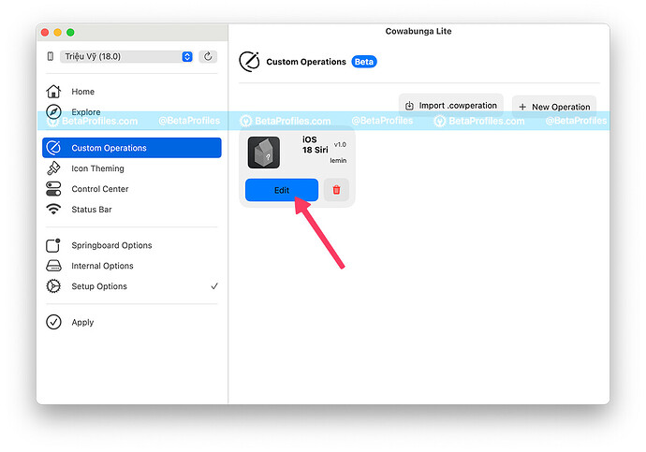](https://forum.betaprofiles.com/uploads/default/original/2X/f/f0bd3313f9bfd61bdc2d744f00f2e3bcf4e1aa24.jpeg)](https://forum.betaprofiles.com/uploads/default/original/2X/f/f0bd3313f9bfd61bdc2d744f00f2e3bcf4e1aa24.jpeg" \o "enable-new-siri-ui-cowabunga-lite-5)

[enable-new-siri-ui-cowabunga-lite-51200×841 86.9 KB](https://forum.betaprofiles.com/uploads/default/original/2X/f/f0bd3313f9bfd61bdc2d744f00f2e3bcf4e1aa24.jpeg" \o "enable-new-siri-ui-cowabunga-lite-5)

[[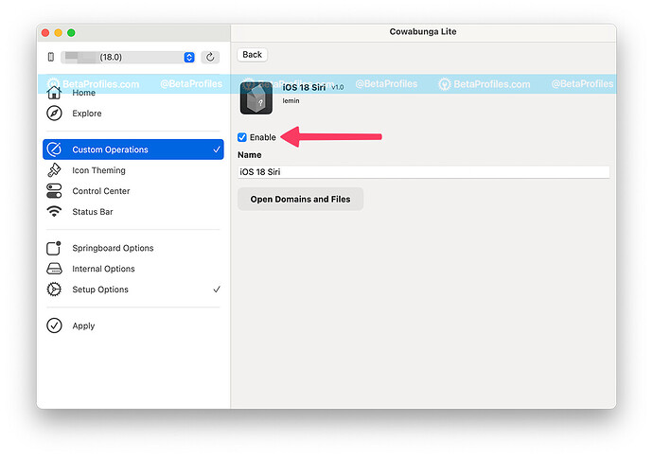](https://forum.betaprofiles.com/uploads/default/original/2X/3/3247408012b437ce20a1866d1feccf38b46fcf04.jpeg)](https://forum.betaprofiles.com/uploads/default/original/2X/3/3247408012b437ce20a1866d1feccf38b46fcf04.jpeg" \o "enable-new-siri-ui-cowabunga-lite-6)

[enable-new-siri-ui-cowabunga-lite-61200×841 84.8 KB](https://forum.betaprofiles.com/uploads/default/original/2X/3/3247408012b437ce20a1866d1feccf38b46fcf04.jpeg" \o "enable-new-siri-ui-cowabunga-lite-6)

1. Click on the **Apply** tab in the left column, then click the **Apply Tweaks** button.

[[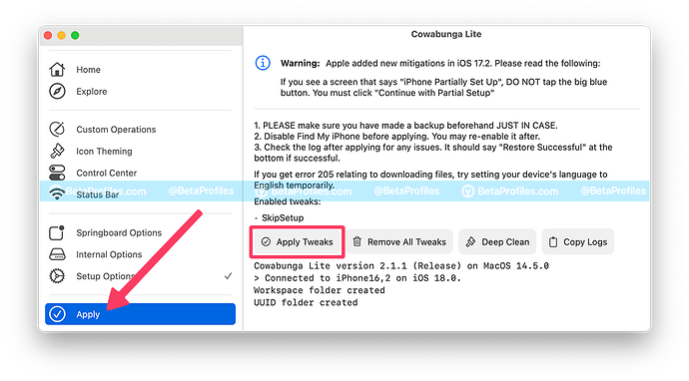](https://forum.betaprofiles.com/uploads/default/original/2X/9/98a6a7a49af76ce7ec702e0837b0d386d9aa38a6.png)](https://forum.betaprofiles.com/uploads/default/original/2X/9/98a6a7a49af76ce7ec702e0837b0d386d9aa38a6.png" \o "enable-new-siri-ui-cowabunga-lite-4)

[enable-new-siri-ui-cowabunga-lite-41200×666 203 KB](https://forum.betaprofiles.com/uploads/default/original/2X/9/98a6a7a49af76ce7ec702e0837b0d386d9aa38a6.png" \o "enable-new-siri-ui-cowabunga-lite-4)

This process may take a while. Your device will restart, and you will see the Setup screen.

 If you see a screen that says “iPhone Partially Set Up”, **DO NOT tap the big blue button**. You must tap on **“Continue with Partial Setup”** and your data will be fine.

**For Windows**

1. Download and install Cowabunga Lite for Windows (you can easily find it on Google).
2. Connect your device via USB cable.
3. Open Cowabunga Lite and ensure the SkipSetup option is selected in the Setup Options tab.
4. In File Explorer, go to %APPDATA%/CowabungaLite/Workspace (or paste the path into the Run app), find your UUID, then go to SkipSetup/ManagedPreferencesDomain/mobile.
5. Add the plist file ([download here 134](https://bit.ly/assistant-plist)) to that folder.
6. Back to Cowabunga Lite, click on the **Apply** tab in the left column, then click the **Apply Tweaks** button.

This process may take a while. Your device will restart, and you will see the Setup screen.

 If you see a screen that says “iPhone Partially Set Up”, **DO NOT tap the big blue button**. You must tap on **“Continue with Partial Setup”** and your data will be fine.

**Special thanks to**[**@LeminLimez**38](https://x.com/leminlimez/)**, who created the Cowabunga Lite tool and discovered this trick.**

**Enable New Siri UI on Mac with macOS Sequoia Beta 1**

1. Open **Terminal**.
2. Enter the following commands one by one, pressing return after each one.  
   defaults write com.apple.assistant bypassDeviceSupportsSAE -bool true  
   and  
   killall Siri

[[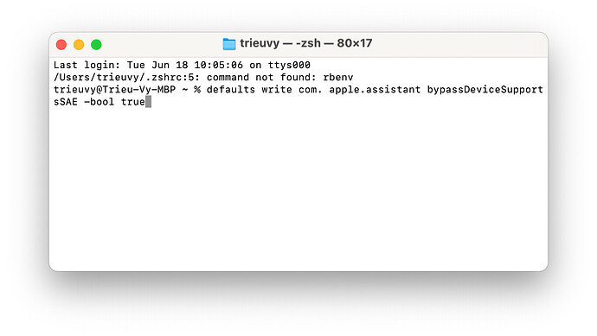](https://forum.betaprofiles.com/uploads/default/original/2X/1/136b3ad5fa5aa3e709848edf56445588190be624.jpeg)](https://forum.betaprofiles.com/uploads/default/original/2X/1/136b3ad5fa5aa3e709848edf56445588190be624.jpeg" \o "enable-new-siri-ui-using terminal on mac)

[enable-new-siri-ui-using terminal on mac1364×770 74.4 KB](https://forum.betaprofiles.com/uploads/default/original/2X/1/136b3ad5fa5aa3e709848edf56445588190be624.jpeg" \o "enable-new-siri-ui-using terminal on mac)

1. Reboot your Mac after to see the new Siri icon in your menu bar.

[[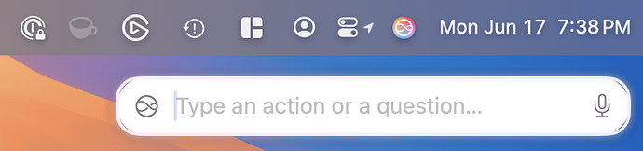](https://forum.betaprofiles.com/uploads/default/original/2X/d/d8ab476a9912514002b08f4de38d531fafd2a893.png)](https://forum.betaprofiles.com/uploads/default/original/2X/d/d8ab476a9912514002b08f4de38d531fafd2a893.png" \o "new siri ui on mac)

[new siri ui on mac858×202 94.5 KB](https://forum.betaprofiles.com/uploads/default/original/2X/d/d8ab476a9912514002b08f4de38d531fafd2a893.png" \o "new siri ui on mac)